PIZZA SALES SQL QUERIES

A.KPI’S

**1.Total revenue:**

SELECT SUM(total_price)AS Total_Revenue from pizza_sales

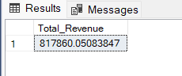

**2. Average Order Value:**

SELECT * FROM pizza_sales

SELECT SUM(total_price) / COUNT(DISTINCT order_id) as Avg_order_Value FROM pizza_sales

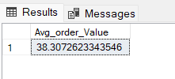

**3. Total Pizzas Sold:**

SELECT * FROM pizza_sales

SELECT SUM(quantity) AS Total_Pizza_Sold from pizza_sales

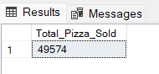

**4.Total Orders Placed:**

SELECT COUNT(DISTINCT order_id) AS Total_orders from pizza_sales

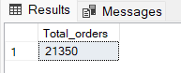

**5. Average Pizzas Per Order**

SELECT CAST(CAST(SUM(quantity) AS DECIMAL(10,2)) /

CAST(COUNT(DISTINCT order_id) AS DECIMAL(10,2)) AS DECIMAL(10,2)) AS Avg_Pizza_Per_Order from pizza_sales

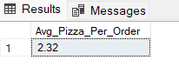

**6. Daily Trend for Total orders:**

SELECT DATENAME(DW, order_date) as order_day, COUNT(DISTINCT order_id) AS Total_Orders

from pizza_sales

GROUP BY DATENAME(DW, order_date)

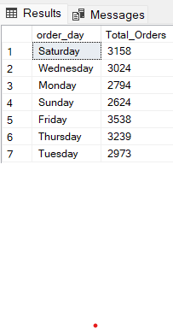

**7. Monthly Trend for Total Orders**

SELECT DATENAME(MONTH, order_date) as Month_Name, COUNT(DISTINCT order_id) AS Total_Orders

FROM pizza_sales

GROUP BY DATENAME(MONTH, order_date)

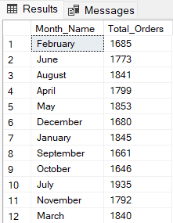

Descending order

SELECT DATENAME(MONTH, order_date) as Month_Name, COUNT(DISTINCT order_id) AS Total_Orders

FROM pizza_sales

GROUP BY DATENAME(MONTH, order_date)

ORDER BY Total_orders DESC

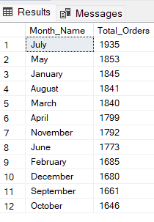

**8. Percentage of Sales by Pizza Category**

SELECT pizza_category, sum(total_price) * 100 / (SELECT sum(total_price) from pizza_sales) AS PCT

from pizza_sales

GROUP BY pizza_category

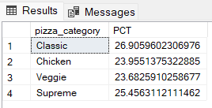

**Total sales included**

SELECT pizza_category, sum(total_price) as Total_Sales,sum(total_price) * 100 / (SELECT sum(total_price) from pizza_sales) AS PCT

from pizza_sales

GROUP BY pizza_category

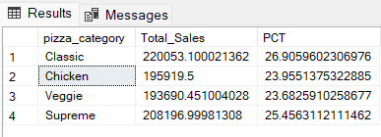

**Filtering the data (eg the month of January)**

SELECT pizza_category, sum(total_price) as Total_Sales,sum(total_price) * 100 / (SELECT sum(total_price) from pizza_sales) AS PCT

from pizza_sales

WHERE MONTH(order_date) = 1

GROUP BY pizza_category

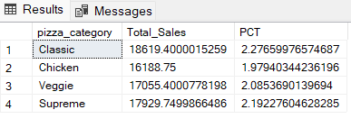

**9. Percentage of Sales by Pizza size**

SELECT pizza_size, sum(total_price) as Total_Sales,sum(total_price) * 100 / (SELECT sum(total_price) from pizza_sales) AS PCT

from pizza_sales

GROUP BY pizza_size

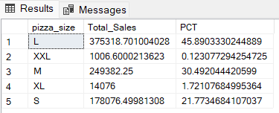

SELECT pizza_size, CAST(sum(total_price)AS DECIMAL(10,2)) as Total_Sales,CAST(sum(total_price) * 100 /

(SELECT sum(total_price) from pizza_sales WHERE DATEPART(quarter, order_date) = 1) AS DECIMAL(10,2)) PCT

from pizza_sales

WHERE DATEPART(quarter, order_date) = 1

GROUP BY pizza_size

ORDER BY PCT DESC

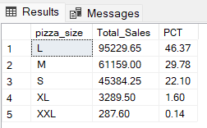

**10.Top 5 Best Pizzas by Revenue**

SELECT TOP 5 pizza_name, SUM(total_price) AS Total_revenue FROM pizza_sales

GROUP BY pizza_name

ORDER BY Total_Revenue DESC

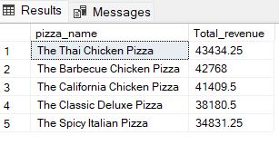

**11. Bottom 5 pizzas by Revenue**

SELECT TOP 5 pizza_name, SUM(total_price) AS Total_revenue FROM pizza_sales

GROUP BY pizza_name

ORDER BY Total_Revenue ASC

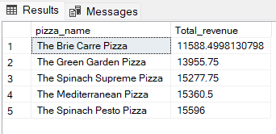

**12. Top 5 Pizzas by Quantity**

SELECT TOP 5 pizza_name, SUM(quantity) AS Total_Quantity FROM pizza_sales

GROUP BY pizza_name

ORDER BY Total_Quantity DESC

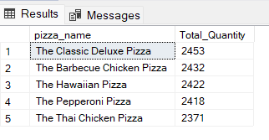

**13. Bottom 5 Pizzas by Quantity**

SELECT TOP 5 pizza_name, SUM(quantity) AS Total_Quantity FROM pizza_sales

GROUP BY pizza_name

ORDER BY Total_Quantity ASC

